**Step1: Launch GIT Bash**



**Step2: Print your working directory and create folder on local drive and go to created folder**

$ pwd

$ mkdir SSLRequests

$ cd SSLRequests

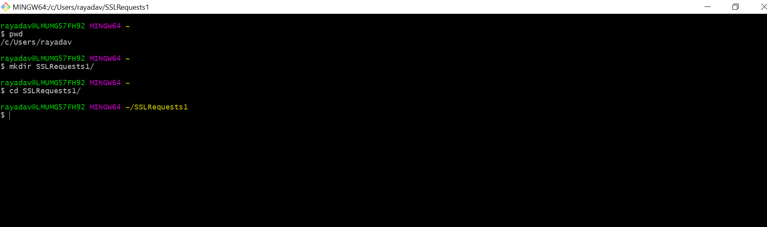

**Step3: Create customSSL.cnf file.**

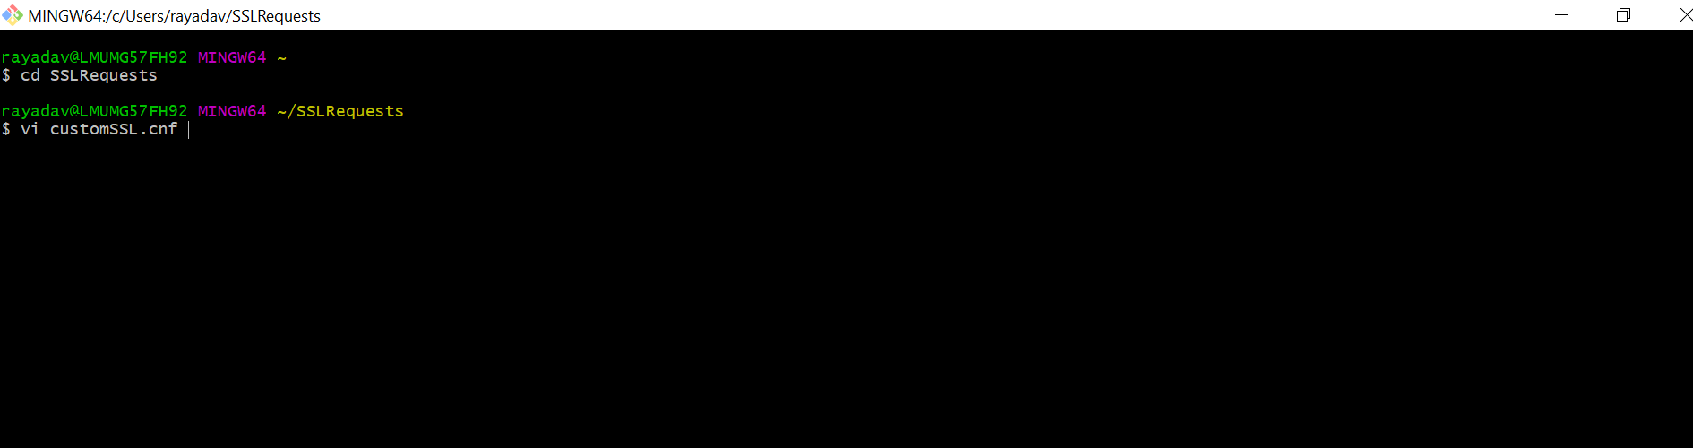

**Step4: Paste all details from customerSSL.cnf file and Modify below parameters in customSSL.cnf with appropriate values and save.**

C = IN

ST = Maharashtra

L = Mumbai

O = Organization Name

CN = [www.domain.com](http://www.domain.com)

OU = Support

emailAddress = [info@domain.com](mailto:info@domain.com)

DNS.1 = subdomain.domain.com

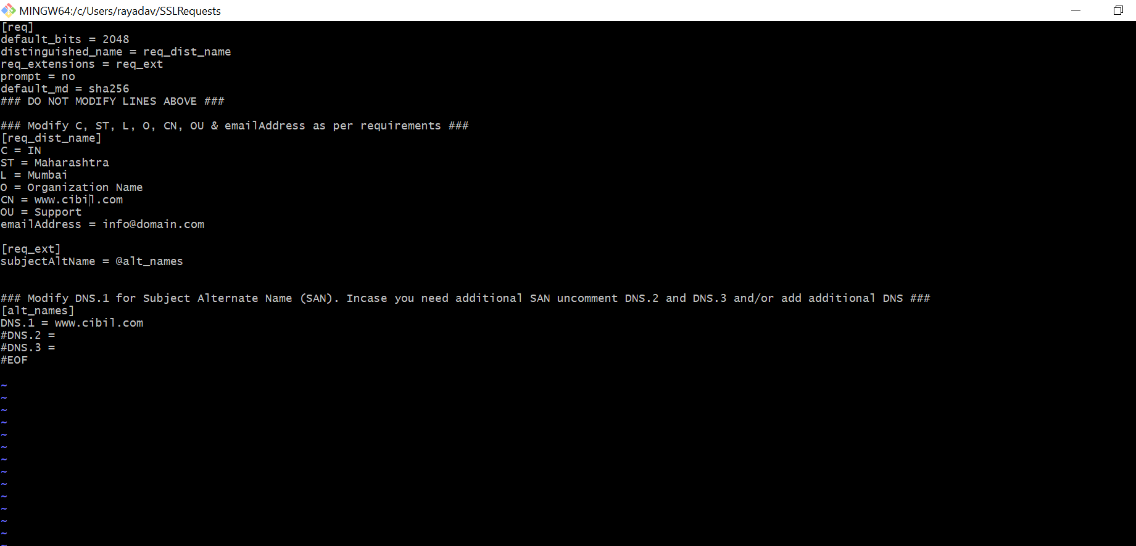

Press esc +:wq then press enter

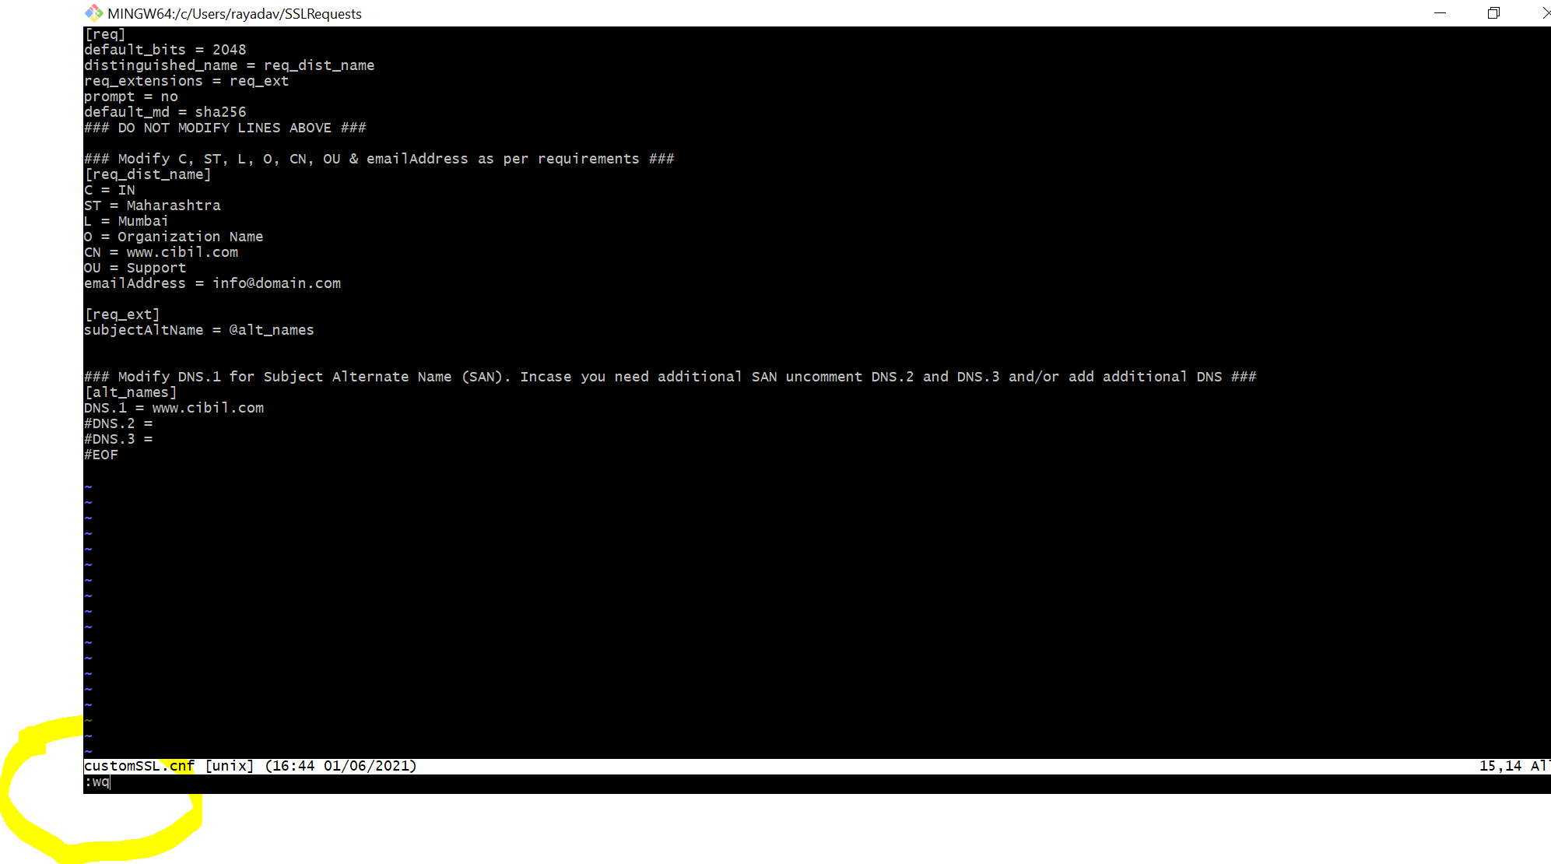

**Step5: Create Private Key**

$ openssl genrsa -out [www.domain.com.key](http://www.domain.com.key) 2048

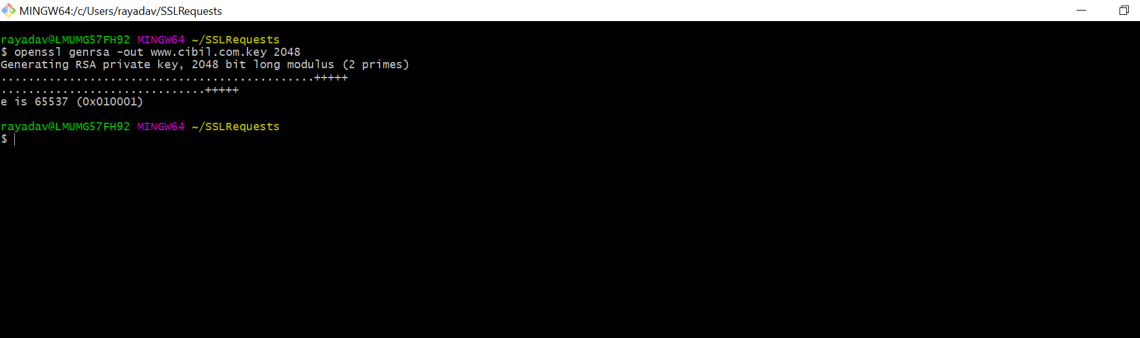

**Step6: Generate CSR**

$ openssl req -config customSSL.cnf -new -key [www.domain.key](http://www.domain.key) -out [www.domain.com.csr](http://www.domain.com.csr)

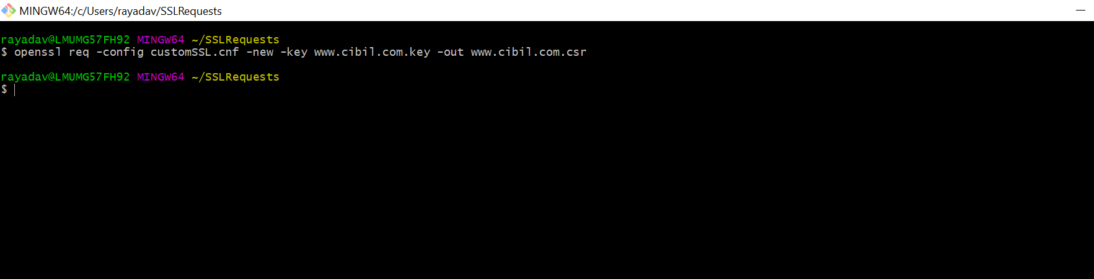

**Step7: Review CSR**

$ openssl req -in [www.domain.csr](http://www.domain.csr) -text -noout